# CLASS: F.Y. MCA SEM: I

**COURSE CODE: MC504 SUBJECT NAME: WEB TECHNOLOGY LAB**

# ROLL NO. 2022510059 BATCH: D

**NAME: CHAITANYA SHETTY EXPERIMENT NO: 03**

**EXPERIMENT TITLE:** Create a responsive website using HTML,CSS and Javascript.

# Objective:

1. To create responsive website
2. Use client side and server side programming and database.

CODE:

<!DOCTYPE html>

<html lang="en">

<head>

    <meta charset="UTF-8">

    <meta http-equiv="X-UA-Compatible" content="IE=edge">

    <meta name="viewport" content="width=device-width, initial-scale=1.0">

    <link rel="stylesheet" href="https://unpkg.com/swiper/swiper-bundle.min.css" />

    <!-- font awesome cdn link  -->

    <link rel="stylesheet" href="https://cdnjs.cloudflare.com/ajax/libs/font-awesome/6.1.1/css/all.min.css">

    <!-- custom css file cdn link  -->

    <link rel="stylesheet" href="css/style.css">

</head>

<body>

<!-- header section starts  -->

<header class="header">

    <a href="#" class="logo"> <i class="fas fa-utensils"></i> Food Zone </a>

    <form action="" class="search-form">

        <input type="search" name="" placeholder="search here..." id="searchBox">

        <label for="searchBox" class="fas fa-search"></label>

    </form>

    <div class="icons">

        <div class="fas fa-search" id="search-btn"></div>

        <div class="fas fa-share" id="theme-btn"></div>

        <div class="fas fa-user" id="login-btn"></div>

        <div class="fas fa-bars" id="menu-btn"></div>

    </div>

    <nav class="navbar">

        <a href="#home">home</a>

        <a href="#packages">packages</a>

        <a href="#services">services</a>

        <a href="#pricing">pricing</a>

        <a href="#review">review</a>

        <a href="#contact">contact</a>

        <a href="#blogs">blogs</a>

    </nav>

</header>

<!-- header section ends -->

<!-- home section starts  -->

<section class="home" id="home">

    <div class="image" data-aos="fade-down">

        <img src="https://cdn.vox-cdn.com/thumbor/8hZcUxUOBb4GV1JiDsz1USpT29w=/385x352:1561x1061/1200x800/filters:focal(831x620:1137x926)/cdn.vox-cdn.com/uploads/chorus_image/image/70609268/Burger_King_Plant_based_Double_Cheeezeburger.0.jpg" alt="">

    </div>

    <div class="content" data-aos="fade-up">

        <h3>Most Tasty Burger For You</h3>

        <p>Find the most tastiest burgers at cut slash prices !!</p>

        <a href="#" class="btn">explore now</a>

    </div>

</section>

<!-- home section ends -->

<!-- filter form section starts  -->

<section class="form-container" data-aos="zoom-in">

    <form action="">

        <div class="inputBox">

            <span>where</span>

            <input type="text" placeholder="search places">

        </div>

        <div class="inputBox">

            <span>When</span>

            <input type="date">

        </div>

        <div class="inputBox">

            <span>Time</span>

            <input type="time">

        </div>

        <input type="submit" value="book now" class="btn">

    </form>

</section>

<!-- filter form section ends -->

<!-- packages section starts  -->

<section class="packages" id="packages">

    <h1 class="heading"> our <span>Foods</span> </h1>

    <div class="box-container">

        <div class="box" data-aos="fade-up">

            <div class="image">

                <img src="images/blog-1.jpg" alt="">

                <h3> <i class="fas fa-utensils"></i> Burger </h3>

            </div>

            <div class="content">

                <div class="price"> 13.00 <span>180</span> </div>

                <p><b>Veggie Burger!</b> That Will Make Your Day</p>

                <a href="#" class="btn"> Order now</a>

            </div>

        </div>

        <div class="box" data-aos="fade-up">

            <div class="image">

                <img src="images/blog-2.jpg" alt="">

                <h3> <i class="fas fa-utensils"></i> Burger </h3>

            </div>

            <div class="content">

                <div class="price"> 200.00 <span>250</span> </div>

                <p><b>Chicken Burger! </b>That Will Win Your Heart</p>

                <a href="#" class="btn"> Order now</a>

            </div>

        </div>

        <div class="box" data-aos="fade-up">

            <div class="image">

                <img src="images/blog-3.jpg" alt="">

                <h3> <i class="fas fa-utensils"></i> Biryani </h3>

            </div>

            <div class="content">

                <div class="price"> 300.00 <span>350</span> </div>

                <p><b>Chicken Biryani!</b> Our Chef's Special</p>

                <a href="#" class="btn"> Order now</a>

            </div>

        </div>

        <div class="box" data-aos="fade-up">

            <div class="image">

                <img src="images/blog-4.jpg" alt="">

                <h3> <i class="fas fa-utensils"></i> Biryani </h3>

            </div>

            <div class="content">

                <div class="price"> 220.00 <span>270</span> </div>

                <p><b>Paneer Biryani!</b> That will make your mouth water</p>

                <a href="#" class="btn"> Order now</a>

            </div>

        </div>

        <div class="box" data-aos="fade-up">

            <div class="image">

                <img src="images/blog-5.jpg" alt="">

                <h3> <i class="fas fa-utensils"></i> Chicken </h3>

            </div>

            <div class="content">

                <div class="price"> 210.00 <span>260</span> </div>

                <p><b>Tandoori Chicken Special</b> That Will Make You Lick Your Fingers</p>

                <a href="#" class="btn"> Order now</a>

            </div>

        </div>

        <div class="box" data-aos="fade-up">

            <div class="image">

                <img src="images/blog-6.jpg" alt="">

                <h3> <i class="fas fa-utensils"></i> Chicken </h3>

            </div>

            <div class="content">

                <div class="price"> 240.00 <span>290</span> </div>

                <p><b>Chicken 65</b> The Must Try Delicacy. You Dont Want To Miss Out On This </p>

                <a href="#" class="btn"> Order now</a>

            </div>

        </div>

    </div>

</section>

<!-- packages section ends -->

<!-- pricing section starts  -->

<section class="pricing" id="pricing">

    <h1 class="heading"> our <span>pricing</span> </h1>

    <div class="box-container">

        <div class="box" data-aos="zoom-in-up">

            <h3> basic plan </h3>

            <div class="price">

                <span>&#8377;</span>

                <span class="amount">300</span>

                <span>/mo</span>

            </div>

            <ul>

                <li>10 days</li>

                <li>food and drinks</li>

                <li>safty guide</li>

                <li>insurance</li>

                <li>luxury hotel</li>

            </ul>

            <a href="#" class="btn">choose plan</a>

        </div>

        <div class="box" data-aos="zoom-in-up">

            <h3> standard plan </h3>

            <div class="price">

                <span>&#8377;</span>

                <span class="amount">500</span>

                <span>/mo</span>

            </div>

            <ul>

                <li>20 days</li>

                <li>food and drinks</li>

                <li>safty guide</li>

                <li>insurance</li>

                <li>luxury hotel</li>

            </ul>

            <a href="#" class="btn">choose plan</a>

        </div>

        <div class="box" data-aos="zoom-in-up">

            <h3> premium plan </h3>

            <div class="price">

                <span>&#8377;</span>

                <span class="amount">999</span>

                <span>/mo</span>

            </div>

            <ul>

                <li>30 days</li>

                <li>food and drinks</li>

                <li>safty guide</li>

                <li>insurance</li>

                <li>luxury hotel</li>

            </ul>

            <a href="#" class="btn">choose plan</a>

        </div>

    </div>

</section>

<!-- pricing section ends -->

<!-- review section starts  -->

<section class="review" id="review">

    <h1 class="heading"> client's <span>review</span> </h1>

    <div class="swiper-container review-slider" data-aos="zoom-in">

        <div class="swiper-wrapper">

            <div class="swiper-slide slide">

                <img src="images/pic-1.png" alt="">

                <h3>Hari Sharma</h3>

                <p>Very good service, good menu … not overly extensive. Food was very good quality all around. They know how to prepare home fries and their omelets are top-notch. Prices were reasonable.</p>

                <div class="stars">

                    <i class="fas fa-star"></i>

                    <i class="fas fa-star"></i>

                    <i class="fas fa-star"></i>

                    <i class="fas fa-star"></i>

                    <i class="fas fa-star-half-alt"></i>

                </div>

            </div>

            <div class="swiper-slide slide">

                <img src="images/pic-2.png" alt="">

                <h3>Kiara Kohli</h3>

                <p>The food is excellent, generous portions and great prices. The service was fast and friendly. I highly recommended it if you’re in Andheri.

                    “The Best Pizza Ever.”</p>

                <div class="stars">

                    <i class="fas fa-star"></i>

                    <i class="fas fa-star"></i>

                    <i class="fas fa-star"></i>

                    <i class="fas fa-star"></i>

                    <i class="fas fa-star-half-alt"></i>

                </div>

            </div>

            <div class="swiper-slide slide">

                <img src="images/pic-3.png" alt="">

                <h3>Suresh Maheshwari</h3>

                <p>The most amazing food ever! And also the staff is so nice to everyone. I highly recommend buying food from here. The best Biryani ever!!</p>

                <div class="stars">

                    <i class="fas fa-star"></i>

                    <i class="fas fa-star"></i>

                    <i class="fas fa-star"></i>

                    <i class="fas fa-star"></i>

                    <i class="fas fa-star-half-alt"></i>

                </div>

            </div>

            <div class="swiper-slide slide">

                <img src="images/pic-4.png" alt="">

                <h3>Siya Chaturvedi</h3>

                <p>My husband and I had our Anniversary dinner at the Food Zone last night. We sat outside on the terrace which was very pretty and private. The food was absolutely delicious!! It could not have been more spectacular! We would highly recommend it to everyone!!</p>

                <div class="stars">

                    <i class="fas fa-star"></i>

                    <i class="fas fa-star"></i>

                    <i class="fas fa-star"></i>

                    <i class="fas fa-star"></i>

                    <i class="fas fa-star-half-alt"></i>

                </div>

            </div>

        </div>

    </div>

</section>

<!-- review section ends -->

<!-- contact section starts  -->

<section class="contact" id="contact">

    <h1 class="heading"> <span>contact</span> us </h1>

    <form action="" data-aos="zoom">

        <div class="inputBox">

            <input type="text" placeholder="name" data-aos="fade-up">

            <input type="email" placeholder="email" data-aos="fade-up">

        </div>

        <div class="inputBox">

            <input type="number" placeholder="number" data-aos="fade-up">

            <input type="text" placeholder="subject" data-aos="fade-up">

        </div>

        <textarea name="" placeholder="your message" id="" cols="30" rows="10" data-aos="fade-up"></textarea>

        <input type="submit" value="send message" class="btn">

    </form>

</section>

<!-- contact section ends -->

<!-- blog section starts  -->

<section class="blogs" id="blogs">

    <h1 class="heading"> our <span>blogs</span> </h1>

    <div class="box-container">

        <div class="box" data-aos="fade-up">

            <div class="image">

                <img src="images/img1.jpg" alt="">

            </div>

            <div class="content">

                <h3>Difference between kolkata and hyderabadi biryani?</h3>

                <a href="#" class="btn">read more</a>

                <div class="icons">

                    <a href="#"> <i class="fas fa-calendar"></i> 11th dec, 2022 </a>

                    <a href="#"> <i class="fas fa-user"></i> by admin </a>

                </div>

            </div>

        </div>

        <div class="box" data-aos="fade-up">

            <div class="image">

                <img src="images/img2.jpg" alt="">

            </div>

            <div class="content">

                <h3>How many types of burger are there?</h3>

                <a href="#" class="btn">read more</a>

                <div class="icons">

                    <a href="#"> <i class="fas fa-calendar"></i> 27th Oct, 2021 </a>

                    <a href="#"> <i class="fas fa-user"></i> by admin </a>

                </div>

            </div>

        </div>

        <div class="box" data-aos="fade-up">

            <div class="image">

                <img src="images/img3.jpg" alt="">

            </div>

            <div class="content">

                <h3>Did you know some facts about pizza?</h3>

                <a href="#" class="btn">read more</a>

                <div class="icons">

                    <a href="#"> <i class="fas fa-calendar"></i> 1st March, 2020 </a>

                    <a href="#"> <i class="fas fa-user"></i> by admin </a>

                </div>

            </div>

        </div>

    </div>

</section>

<!-- blog section ends -->

<!-- footer section starts  -->

<section class="footer">

    <div class="box-container">

        <div class="box" data-aos="fade-up">

            <h3>our branches</h3>

            <a href="#"> <i class="fas fa-map-marker-alt"></i> Mumbai </a>

            <a href="#"> <i class="fas fa-map-marker-alt"></i> Kolkata </a>

            <a href="#"> <i class="fas fa-map-marker-alt"></i> Delhi </a>

            <a href="#"> <i class="fas fa-map-marker-alt"></i> Bangalore </a>

            <a href="#"> <i class="fas fa-map-marker-alt"></i> Hyderabad </a>

        </div>

        <div class="box" data-aos="fade-up">

            <h3>quick links</h3>

            <a href="#"> <i class="fas fa-chevron-right"></i> home </a>

            <a href="#"> <i class="fas fa-chevron-right"></i> packages </a>

            <a href="#"> <i class="fas fa-chevron-right"></i> services </a>

            <a href="#"> <i class="fas fa-chevron-right"></i> pricing </a>

            <a href="#"> <i class="fas fa-chevron-right"></i> review </a>

            <a href="#"> <i class="fas fa-chevron-right"></i> contact </a>

            <a href="#"> <i class="fas fa-chevron-right"></i> blogs </a>

        </div>

        <div class="box" data-aos="fade-up">

            <h3>contact info</h3>

            <a href="#"> <i class="fas fa-phone"></i> +123-456-7890 </a>

            <a href="#"> <i class="fas fa-phone"></i> +111-222-3333 </a>

            <a href="#"> <i class="fas fa-envelop"></i> foodzone@gmail.com </a>

            <a href="#"> <i class="fas fa-map-marker-alt"></i> Mumbai, India - 400071 </a>

        </div>

        <div class="box" data-aos="fade-up">

            <h3>follow us</h3>

            <a href="#"> <i class="fab fa-facebook-f"></i> facebook </a>

            <a href="#"> <i class="fab fa-twitter"></i> twitter </a>

            <a href="#"> <i class="fab fa-instagram"></i> instagram </a>

            <a href="#"> <i class="fab fa-linkedin"></i> linkedin </a>

            <a href="#"> <i class="fab fa-pinterest"></i> pinterest </a>

        </div>

    </div>

    <div class="credit"> All Rights <span>FoodZone</span> | all rights reserved </div>

</section>

<!-- footer section ends -->

<script src="https://cdnjs.cloudflare.com/ajax/libs/aos/2.3.4/aos.js"></script>

<script src="https://unpkg.com/swiper/swiper-bundle.min.js"></script>

<!-- custom js file link  -->

<script src="js/script.js"></script>

<script>

AOS.init({

    duration:800,

    delay:400

});

</script>

</body>

</html>

CSS File

@import url('https://fonts.googleapis.com/css2?family=Poppins:wght@300;600;700&display=swap');

:root{

    --orange:#F79F1F;

    --text-color-1:#444;

    --text-color-2:#666;

    --bg-color-1:#fff;

    --bg-color-2:#eee;

    --box-shadow:0 .5rem 1.5rem rgba(0,0,0,.1);

}

*{

    font-family: 'Poppins', sans-serif;

    margin:0; padding:0;

    box-sizing: border-box;

    outline: none; border:none;

    text-decoration: none;

    text-transform: capitalize;

    transition:all .2s linear;

}

html{

    font-size: 62.5%;

    overflow-x: hidden;

    scroll-padding-top: 7rem;

    scroll-behavior: smooth;

}

html::-webkit-scrollbar{

    width:.8rem;

}

html::-webkit-scrollbar-track{

    background:transparent;

}

html::-webkit-scrollbar-thumb{

    background:var(--orange);

    border-radius: 5rem;

}

body{

    background:var(--bg-color-2);

}

body.active{

    --text-color-1:#fff;

    --text-color-2:#eee;

    --bg-color-1:#333;

    --bg-color-2:#222;

    --box-shadow:0 .5rem 1.5rem rgba(0,0,0,.4);

}

section{

    padding:2rem 7%;

}

.heading{

    text-align: center;

    padding-bottom: 2rem;

    color:var(--text-color-1);

    font-size: 4rem;

}

.heading span{

    position: relative;

    z-index: 0;

}

.heading span::before{

    content: '';

    position: absolute;

    left: 0;

    z-index: -1;

    background: var(--orange);

    height: 100%;

    width: 100%;

    clip-path: polygon(0 90%, 100% 83%, 100% 100%, 0% 100%);

}

.btn{

    margin-top: 1rem;

    display: inline-block;

    padding:.8rem 3rem;

    font-size: 1.7rem;

    color:#fff;

    background:#ab6806;

    border-radius: .5rem;

    cursor: pointer;

}

.btn:hover{

    letter-spacing: .2rem;

}

.header{

    position: fixed;

    top:0; left:0; right:0;

    background:var(--bg-color-1);

    box-shadow: var(--box-shadow);

    padding: 1.5rem 7%;

    z-index: 1000;

    display: flex;

    align-items: center;

    justify-content: space-between;

}

.header .logo{

    font-weight: bolder;

    font-size: 2.5rem;

    color:var(--text-color-1);

}

.header .logo i{

    color:var(--orange);

}

.header .search-form{

    background:var(--bg-color-2);

    border-radius: .5rem;

    display: flex;

    align-items: center;

    height: 4.5rem;

    width:50rem;

}

.header .search-form input{

    height:100%;

    width:100%;

    background:none;

    text-transform: none;

    font-size: 1.5rem;

    color:var(--text-color-1);

    padding:1rem;

}

.header .search-form label{

    font-size: 2rem;

    margin-right: 1.5rem;

    color:var(--text-color-1);

    cursor: pointer;

}

.header .search-form label:hover{

    color:var(--orange);

}

.header .icons div{

    height:4.5rem;

    width:4.5rem;

    line-height:4.5rem;

    font-size: 2rem;

    border-radius: .5rem;

    margin-left: .5rem;

    background:var(--bg-color-2);

    color:var(--text-color-1);

    cursor: pointer;

    text-align: center;

}

.header .icons div:hover{

    color:#fff;

    background:var(--orange);

}

#search-btn{

    display:none;

}

.header .navbar{

    position:absolute;

    top:115%; right:7%;

    background:var(--bg-color-1);

    border-radius: .5rem;

    box-shadow: var(--box-shadow);

    width:25rem;

    transform:scale(0);

    transform-origin: top right;

}

.header .navbar.active{

    transform:scale(1);

}

.header .navbar a{

    display:block;

    margin:1rem;

    padding:1rem;

    font-size: 1.5rem;

    color:var(--text-color-1);

    border-radius: .5rem;

}

.header .navbar a:hover{

    color:var(--orange);

    background:var(--bg-color-2);

    padding-left: 2rem;

}

.home{

    display: flex;

    align-items: center;

    flex-wrap: wrap;

    gap:1.5rem;

    padding-top: 7rem;

    background: #fff;

}

.home .image{

    flex:1 1 45rem;

}

.home .image img{

    width: 100%;

}

.home .content{

    flex:1 1 45rem;

}

.home .content h3{

    color:var(--text-color-1);

    font-size: 4rem;

}

.home .content p{

    color:var(--text-color-2);

    font-size: 1.7rem;

    line-height: 1.7;

    padding:1rem 0;

}

.form-container form{

    background: var(--bg-color-1);

    box-shadow: var(--box-shadow);

    border-radius: .5rem;

    padding:2rem;

    display: flex;

    flex-wrap: wrap;

    gap:1rem;

    align-items: center;

}

.form-container form .inputBox{

    flex:1 1 23rem;

}

.form-container form .inputBox span{

    font-size: 1.7rem;

    color:var(--text-color-2);

}

.form-container form .inputBox input{

    font-size: 1.5rem;

    color:var(--text-color-1);

    background:var(--bg-color-2);

    border-radius: .5rem;

    margin:.5rem 0;

    text-transform: none;

    width: 100%;

    padding:1rem;

}

.form-container form .btn{

    flex:1 1 23rem;

}

.packages .box-container{

    display: grid;

    grid-template-columns: repeat(auto-fit, minmax(30rem, 1fr));

    gap:1.5rem;

}

.packages .box-container .box{

    background:var(--bg-color-1);

    border-radius: .5rem;

    box-shadow: var(--box-shadow);

}

.packages .box-container .box .image{

    height:25rem;

    width: 100%;

    padding:1.5rem;

    position: relative;

}

.packages .box-container .box .image img{

    height:100%;

    width: 100%;

    object-fit: cover;

    border-radius: .5rem;

}

.packages .box-container .box .image h3{

    position: absolute;

    top:2.5rem; left:2.5rem;

    font-size: 2rem;

    color:#fff;

    background: rgba(0,0,0,.5);

    border-radius: .5rem;

    font-weight: lighter;

    padding:.5rem 1.5rem;

}

.packages .box-container .box .image h3 i{

    color:var(--orange);

}

.packages .box-container .box .content{

    padding:1.5rem;

    padding-top: 0;

}

.packages .box-container .box .content .price{

    font-weight: 600;

    color:var(--text-color-1);

    font-size: 2.5rem;

}

.packages .box-container .box .content .price span{

    font-weight: lighter;

    color:var(--text-color-2);

    font-size: 1.5rem;

    text-decoration: line-through;

}

.packages .box-container .box .content p{

    font-size: 1.5rem;

    padding:.5rem 0;

    color:var(--text-color-2);

    line-height: 1.7;

}

.pricing .box-container{

    display: grid;

    grid-template-columns: repeat(auto-fit, minmax(30rem, 1fr));

    gap:1.5rem;

}

.pricing .box-container .box{

    background:var(--bg-color-1);

    border-radius: .5rem;

    box-shadow: var(--box-shadow);

    padding:2rem;

    text-align: center;

}

.pricing .box-container .box h3{

    padding:1rem;

    background: var(--bg-color-2);

    border-radius: .5rem;

    font-size: 2rem;

    color:var(--text-color-1);

}

.pricing .box-container .box .price{

    padding-top: 2rem;

}

.pricing .box-container .box .price span{

    font-size: 2rem;

    color:var(--text-color-2);

}

.pricing .box-container .box .price .amount{

    font-size: 5rem;

    color:var(--text-color-1);

    font-weight: bolder;

}

.pricing .box-container .box ul{

    padding: .5rem 0;

    list-style: none;

}

.pricing .box-container .box ul li{

    padding: 1rem 0;

    font-size: 1.7rem;

    color:var(--text-color-2);

}

.review .review-slider{

    box-shadow: var(--box-shadow);

}

.review .review-slider .slide{

    background: var(--bg-color-1);

    border-radius: .5rem;

    text-align: center;

    padding: 3rem;

}

.review .review-slider .slide img{

    height: 10rem;

    width: 10rem;

    border-radius: 50%;

    object-fit: cover;

    margin-bottom: .5rem;

}

.review .review-slider .slide h3{

    font-size: 2.5rem;

    color:var(--text-color-1);

}

.review .review-slider .slide p{

    font-size: 1.6rem;

    color:var(--text-color-2);

    line-height: 1.7;

    padding: 1rem 0;

}

.review .review-slider .slide .stars{

    padding: 1rem 0;

    padding-bottom: 1.5rem;

}

.review .review-slider .slide .stars i{

    font-size: 2rem;

    color:var(--orange);

}

.swiper-pagination-bullet-active{

    background: var(--orange);

}

.contact form{

    max-width: 70rem;

    margin: 0 auto;

    text-align: center;

}

.contact form .inputBox{

    display: flex;

    flex-wrap: wrap;

    justify-content: space-between;

}

.contact form textarea,

.contact form .inputBox input{

    width: 100%;

    padding:1rem;

    font-size: 1.6rem;

    color:var(--text-color-1);

    margin:.7rem 0;

    background: var(--bg-color-1);

    box-shadow: var(--box-shadow);

    text-transform: none;

    border-radius: .5rem;

}

.contact form textarea{

    height: 20rem;

    resize: none;

}

.contact form .inputBox input{

    width: 49%;

}

.blogs .box-container{

    display: grid;

    grid-template-columns: repeat(auto-fit, minmax(30rem, 1fr));

    gap:1.5rem;

}

.blogs .box-container .box{

    background:var(--bg-color-1);

    border-radius: .5rem;

    box-shadow: var(--box-shadow);

    padding:2rem;

}

.blogs .box-container .box .image{

    height: 20rem;

    width: 100%;

    overflow:hidden;

    border-radius: .5rem;

    background: var(--bg-color-2);

}

.blogs .box-container .box .image img{

    height: 100%;

    width: 100%;

}

.blogs .box-container .box:hover .image img{

    transform:scale(1.2);

}

.blogs .box-container .box .content{

    padding-top: 1rem;

}

.blogs .box-container .box .content h3{

   font-size: 2rem;

   color:var(--text-color-1);

   line-height: 1.5;

}

.blogs .box-container .box .content .icons{

    display: flex;

    justify-content: space-between;

    border-top: .1rem solid var(--text-color-2);

    margin-top: 2rem;

    padding-top: 1.5rem;

}

.blogs .box-container .box .content .icons a{

    font-size: 1.5rem;

    color:var(--text-color-2);

}

.blogs .box-container .box .content .icons a:hover{

    color:var(--orange);

}

.blogs .box-container .box .content .icons a i{

    padding-right: .5rem;

    color:var(--orange);

}

.footer{

    background: var(--bg-color-1);

}

.footer .box-container{

    display: grid;

    grid-template-columns: repeat(auto-fit, minmax(22rem, 1fr));

    gap:1.5rem;

}

.footer .box-container .box h3{

    font-size: 2.5rem;

    color:var(--text-color-1);

    padding:1rem 0;

}

.footer .box-container .box a{

    display: block;

    font-size: 1.5rem;

    color:var(--text-color-2);

    padding:1rem 0;

}

.footer .box-container .box a i{

    padding-right: .5rem;

    color:var(--orange);

}

.footer .box-container .box a:hover i{

    padding-right: 2rem;

}

.footer .credit{

    font-size: 2rem;

    text-align: center;

    border-top: .1rem solid var(--text-color-2);

    padding:1rem;

    padding-top: 2rem;

    margin-top: 2rem;

    color:var(--text-color-2);

}

.footer .credit span{

    color:var(--orange);

}

/* media queries  */

@media (max-width:991px){

    html{

        font-size: 55%;

    }

    .header{

        padding:1.5rem 2rem;

    }

    section{

        padding:2rem;

    }

}

@media (max-width:768px){

    .header .navbar{

        right: 2rem;

    }

    .header .login-form{

        right: 2rem;

    }

    #search-btn{

        display:inline-block;

    }

    .header .search-form{

        position: absolute;

        top:115%; right: 2rem;

        background:var(--bg-color-1);

        border-radius: .5rem;

        width: 90%;

        box-shadow: var(--box-shadow);

        transform:scale(0);

        transform-origin: top right;

    }

    .header .search-form.active{

        transform:scale(1);

    }

}

@media (max-width:450px){

    html{

        font-size: 50%;

    }

    .contact form .inputBox input{

        width: 100%;

    }

}

Javascript file:

let navbar = document.querySelector('.navbar')

document.querySelector('#menu-btn').onclick = () =>{

    navbar.classList.toggle('active');

    loginForm.classList.remove('active');

    searchForm.classList.remove('active');

}

let searchForm = document.querySelector('.search-form')

document.querySelector('#search-btn').onclick = () =>{

    searchForm.classList.toggle('active');

    navbar.classList.remove('active');

    loginForm.classList.remove('active');

}

window.onscroll = () =>{

    navbar.classList.remove('active');

    loginForm.classList.remove('active');

    searchForm.classList.remove('active');

}

var swiper = new Swiper(".review-slider", {

    loop:true,

    spaceBetween: 30,

    centeredSlides: true,

    autoplay: {

        delay: 5500,

        disableOnInteraction: false,

    },

    pagination: {

        el: ".swiper-pagination",

    },

});

OUTPUT:

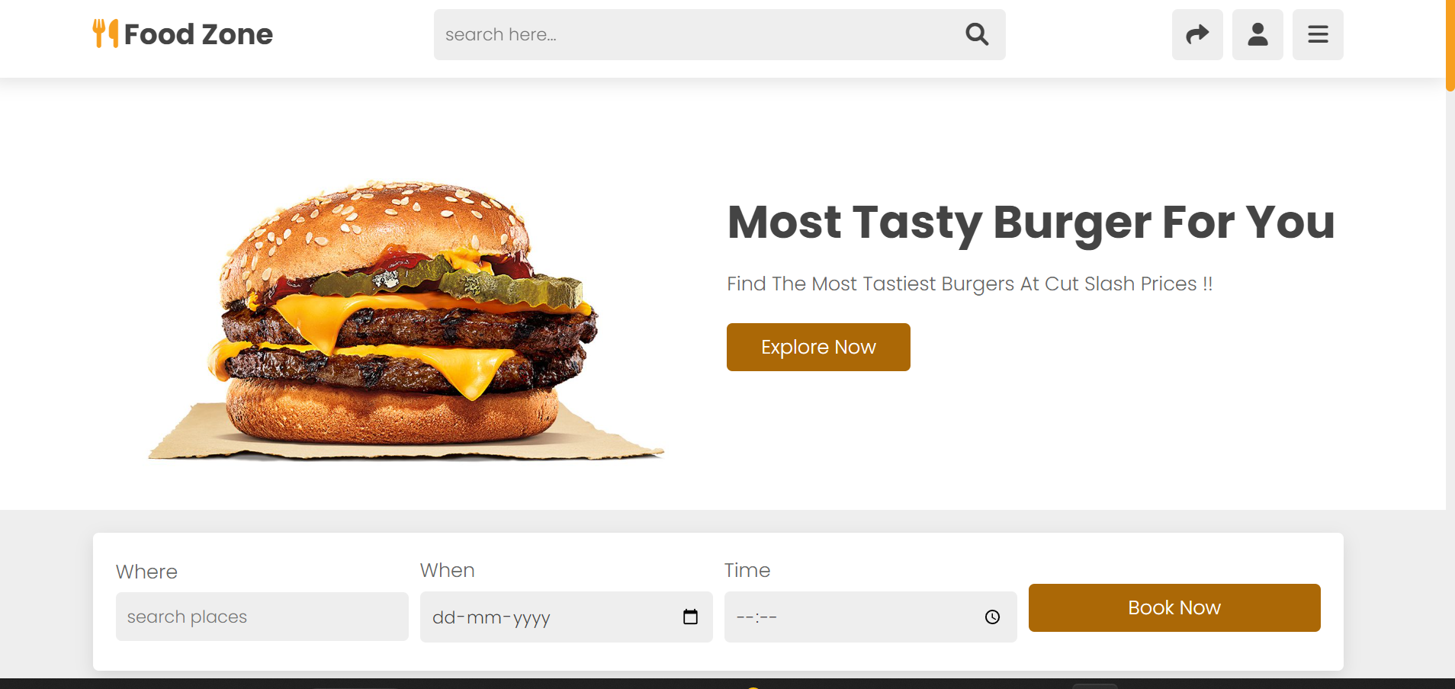

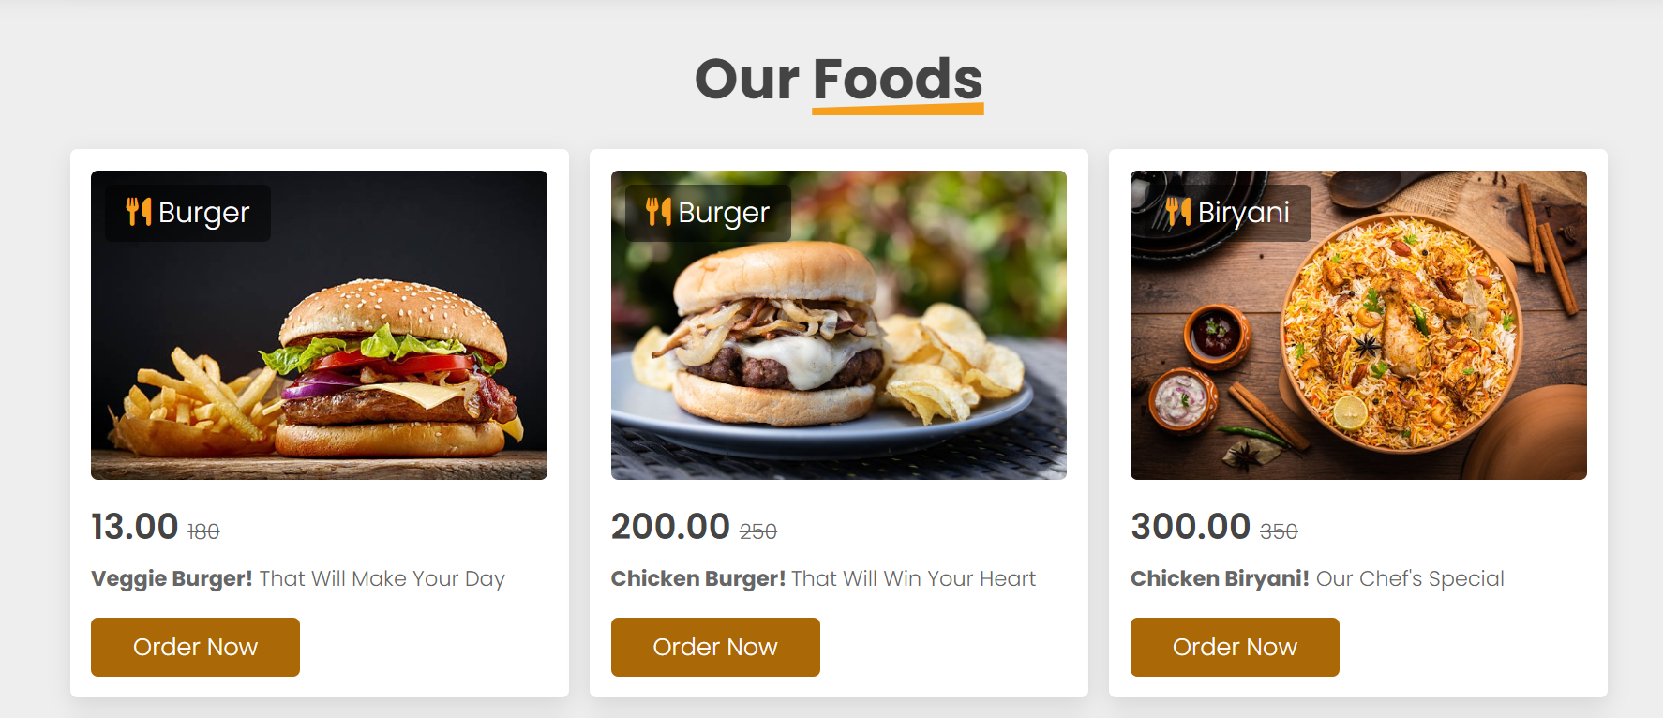

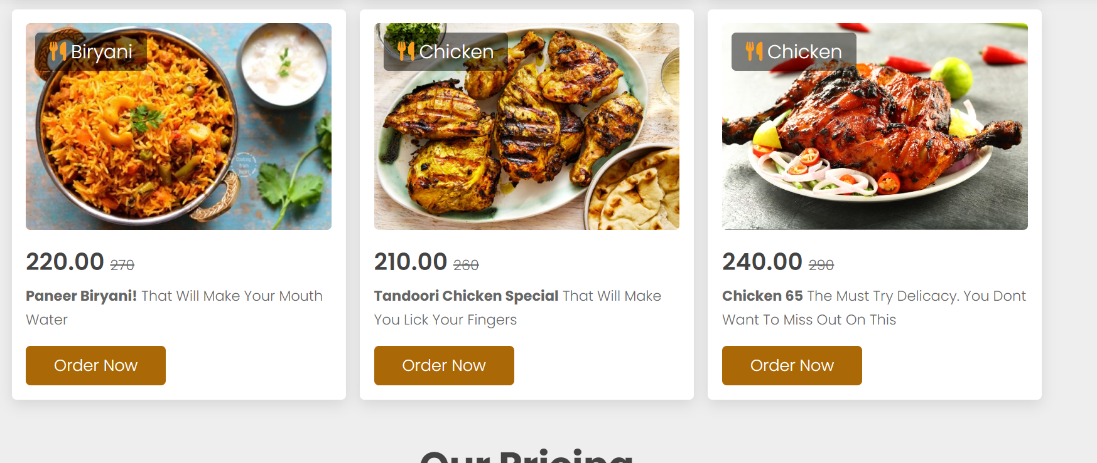 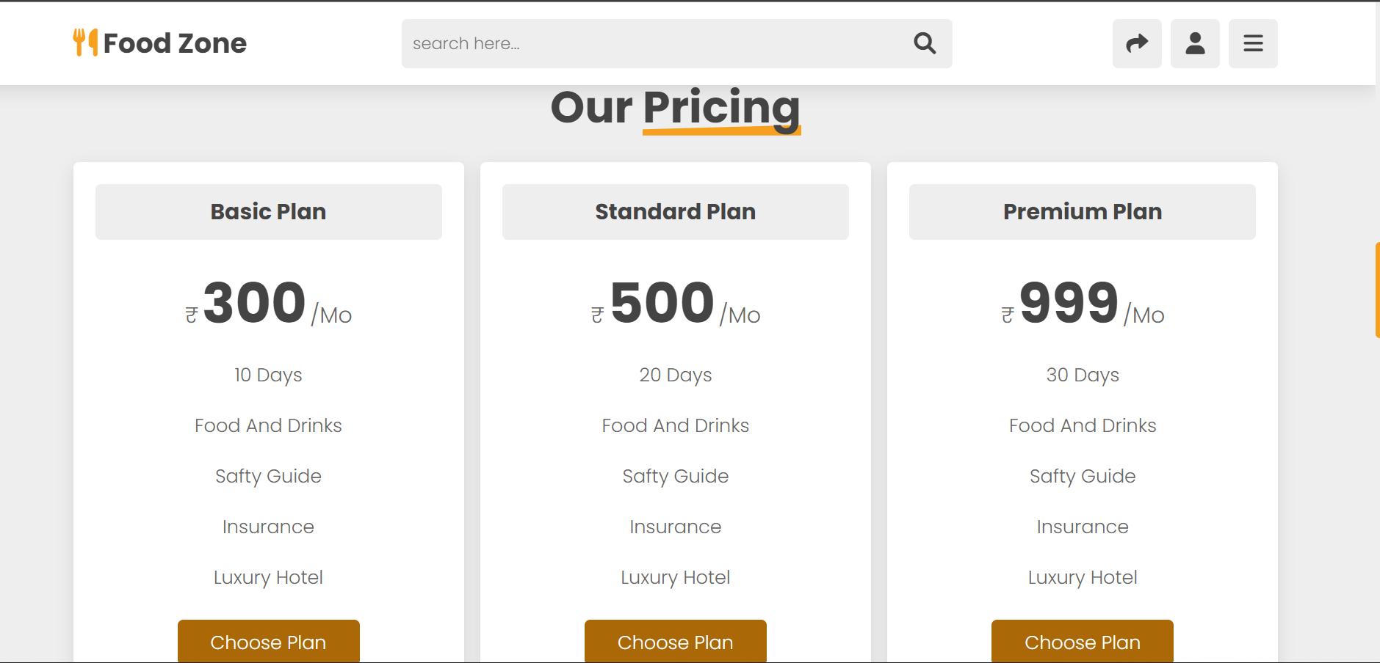

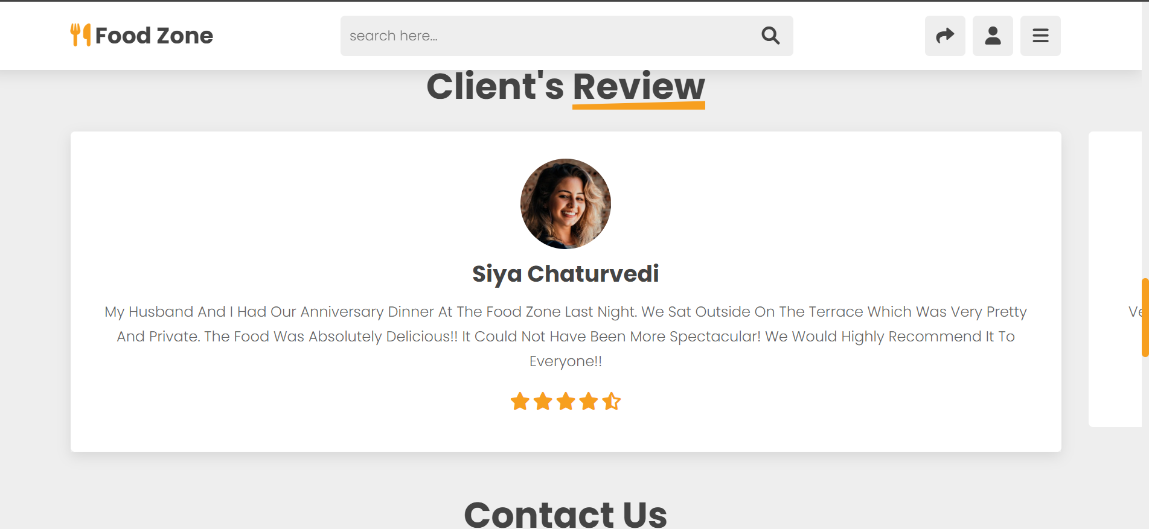

The site can swipe through reviews by dragging the mouse

